Figure 2.7 provides an overview of the Bluetooth LE Audio architecture, putting a name, or

more precisely, a set of letters, to all of the 18 specifications which make up the GAF, along

with the four in the current top level profiles. The dotted boxes indicate sets of profiles and

services which work together. In most cases there is a one-to-one relationship of a profile and

a service, although in the case of the Basic Audio Profile (BAP)8 and the Voice Control Profile

(VCP), **one profile can operate on three different services**. The Public Broadcast Profile (PBP)

is an anomaly, as it’s a profile without a service, but that’s one of the consequences of

broadcast, as you cannot have a traditional Client-Server interaction when there is no

connection.

Profile,可以理解为一种规范，一种通信协议，profile存在于从机中。SIG规定了一些profile，如心率计，防丢器，HID OVER GATT等等。每个Profile中都包含多个Service。每个Service代表从机的一个能力。

service可以理解为一个服务，在BLE从机中，可以有多个服务，譬如系统电量信息服务，系统信息服务，每个Service又包含多个Characteristic。每个具体的Characteristic值才是BLE通信的主体。

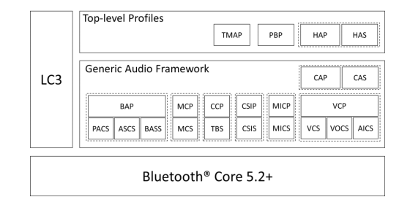

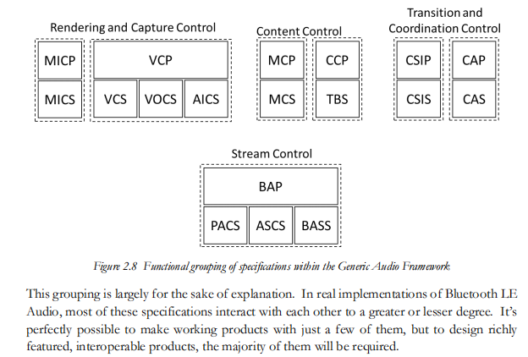

PACS – the Published Audio Capabilities Service

PACS is that it is a statement of fact about the total capabilities of an Acceptor

## 2.2. Behavior（）

PACS can be instantiated on devices that can accept the establishment of **unicast Audio Streams** or devices that can receive **broadcast Audio Streams**. Examples of such devices are speakers, headsets, hearing aids, and microphones

Servers expose one or more sets of audio capabilities and audio availability. Sets of audio

capabilities, known as Published Audio Capability (PAC) records, are exposed by using either the Sink PAC characteristic or Source PAC characteristic. Clients can discover and read these characteristics, and servers can notify these characteristics

此服务定义了本设备支持的音频能力，包括但不限于支持的编解码器个数以及各编解码能力，通过此项服务，可获取设备的音频能力。

Source PAC为音频发送能力属性

Sink PAC为音频接收能力属性

PAC record

The server may expose multiple supported values for a given parameter in a PAC record where the format of that parameter value allows, such as bitfields.

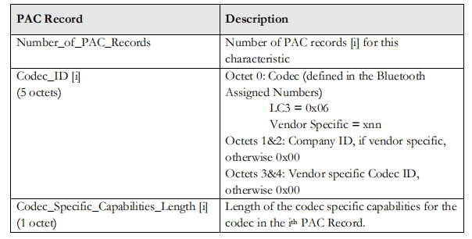

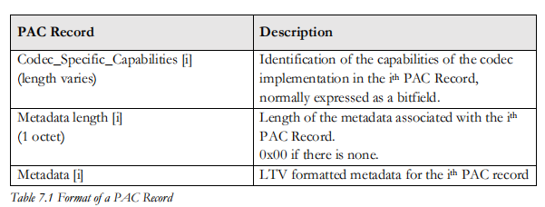

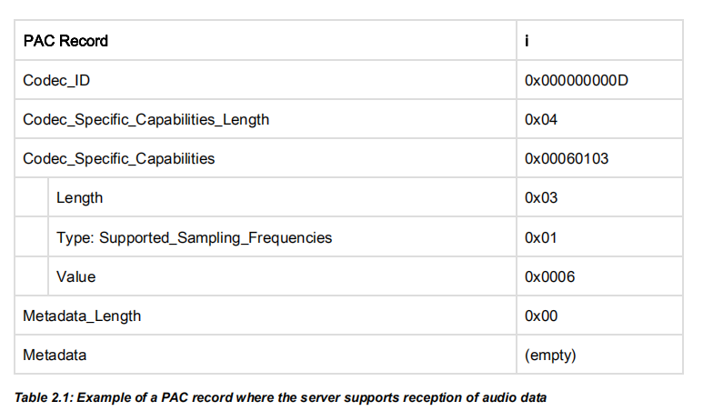

Every Bluetooth LE Audio specification includes at least one PAC record using the **LC3**

**codec**, as this is mandated in BAP, which is the lowest layer of the Generic Audio Framework.

The assigned number for LC3 is 0x06, so every Bluetooth LE Audio Acceptor will have at

least one PAC record with the Codec_ID of 0x0000000006.

Note that the Codec_ID is the Coding Format described in the Host Controller Interface Assigned Number list, and not the Audio Codec ID defined in the Audio/Video assigned numbers list.

### Codec Specific Capabilities:

The Codec_Specific_Capabilities requirements for LC3 are defined in BAP Section 4.3.1 and

consist of five LTV structures.

#### Supported_Sampling_Frequencies (Type = 0x01) mandatory

which is a bitfield of sampling frequencies covering the range from 8 kHz

to 384 kHz. Support for each value is indicated by setting the corresponding bit to one. This

LTV is mandatory.

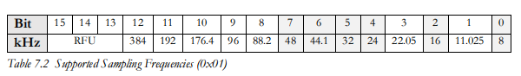

The Supported_Frame_Durations LTV (Type = 0x02) mandatory

bits 4 and 5 can indicate whether one of them is preferred

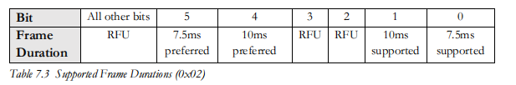

The Supported_Audio_Channel_Counts LTV (Type = 0x03)

indicates the number of Audio Channels which can be included in a CIS or BIS.

Bits 0 to 7 indicate the number of channel counts that are supported, with a value of 1 representing a supported option. At least one bit must be set, otherwise it indicates that no audio channel can be set up.

**If multiplexing is not supported, then the Channel Count is 1 and this LTV structure can be omitted.**

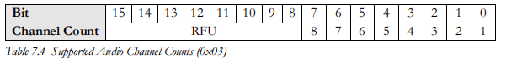

The Supported_Octets_Per_Codec_Frame LTV (Type = 0x04) mandatory

This structure consists of two pairs of two octets, with the lower pair (Octets 0

and 1) specifying the minimum number of octets per codec frame and the upper pair the

maximum number of octets per codec frame

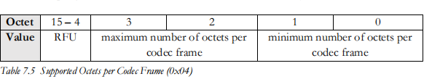

The Supported_Max_Codec_Frames_Per_SDU (Type = 0x05)：

a single octet stating the maximum number of codec frames which can be packed into a single SDU

Minimum PACS capabilities for an Audio Sink

The mandatory BAP LC3 requirements mean that an Acceptor which is acting as a unicast Audio Sink, i.e., receiving an Audio Stream, has to support reception of a minimum of one audio channel at 16 and 24kHz sampling frequencies with a 10ms frame duration. Similarly, every Acceptor which is acting as a unicast Audio Source, i.e., transmitting an Audio Stream, has to support encoding a minimum of one audio channel at a 16 kHz sampling frequency with a 10ms frame duration

For the following example, which illustrates PAC records, we’ll just look at the Sink PAC

characteristic. The same principles apply to the Source PAC characteristic.

The mandatory 16kHz sampling rate for both Audio Sink and Source requires support for 40

octets per SDU, whilst the 24 kHz sampling rate for the Audio Sink requires 60 octets.

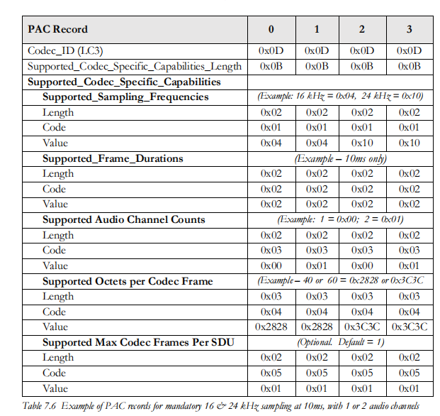

The example above, which is the baseline support needed for BAP, results in four PAC records, which is manageable. Trying the do the same thing for TMAP would require at least ninety-six individual PAC records.

## Service characteristics

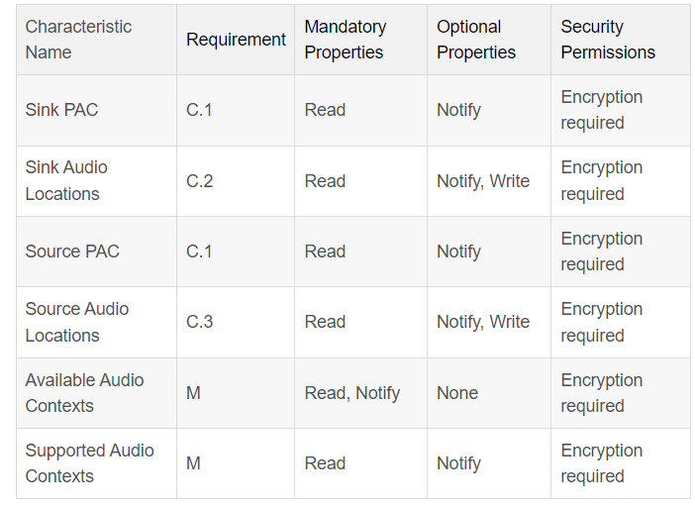

Audio Location：To accomplish this, devices need to know what spatial information they are meant to receive, for example, a left or a right stream from a stereo input. They do this by specifying an Audio Location

### Sink PAC

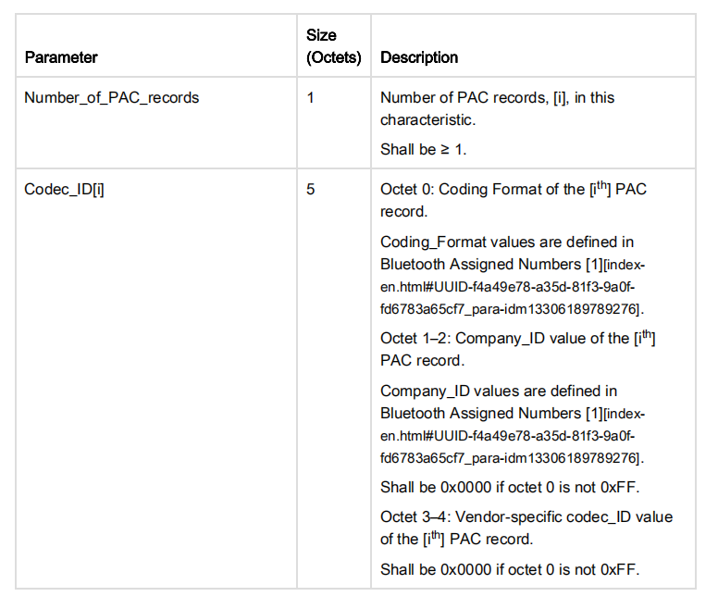

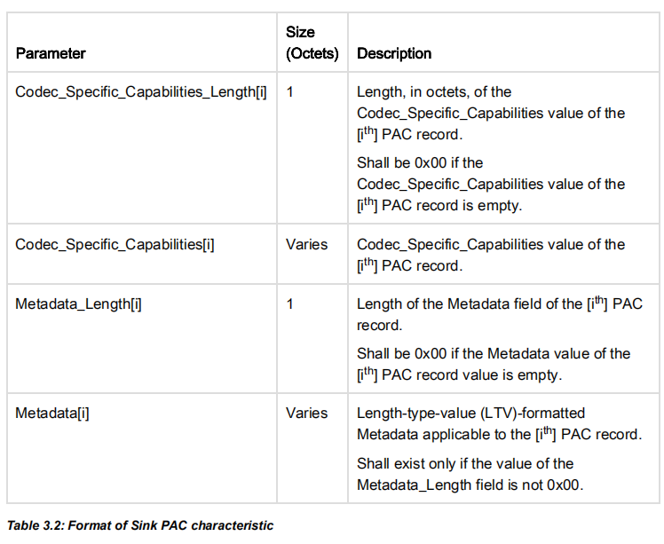

Sink PAC behavior: **The Sink PAC characteristic** returns its characteristic value when read by a client.

Notifications: the server shall support notifications for the Sink PAC characteristic instance containing the PAC record that can change

### Sink Audio Locations

The Sink Audio Locations characteristic is used to expose the supported Audio Locations when the server supports reception of audio data

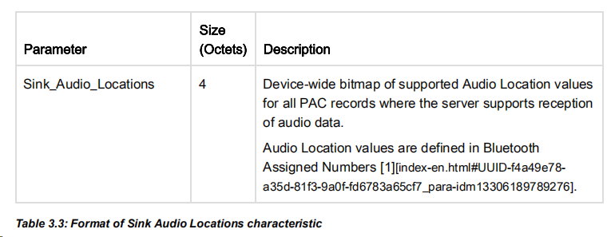

Read/written by a client, notifications

The server may support writes to the Sink Audio Locations characteristic value by clients.

### Source PAC

为音频发送能力属性，当设备支持音频发送时才需要定义

### Supported Audio Contexts

What this characteristic does is list the Context Types (i.e., the use cases) for which the Acceptor can make itself unavailable, in order to prevent any Initiator trying to establish an Audio Stream for use cases that the Acceptor is not interested in.

**static list**, which will only change as a result of a software update which changes the Acceptor’s functionality.

### Available Audio Contexts

inform an Initiator that it is not available for specific Context Types which it has claimed support for in the Supported_Audio_Contexts characteristic.

Not are static, an Acceptor may update its Available_Audio_Contexts values at any time, notifying connected Initiators when it does so.

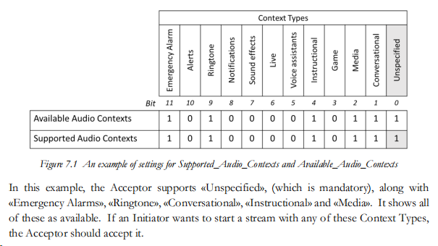

If the Initiator wanted to set up a stream to carry key-press sounds, which are covered by the

«Sound Effects» Context Type it can. This is because the Available_Audio_Contexts bitmap

shows «Unspecified» is available.

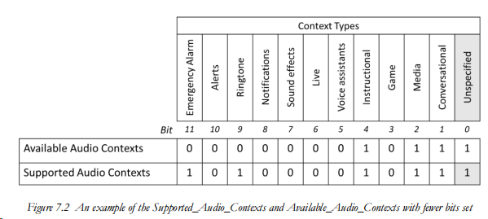

«Emergency Alarm» and «Ringtone» are supported, but are not currently marked as available in the Available_Audio_Contexts characteristic. This means that if an Initiator tries to establish a stream associated with these Context Types it will be rejected by the Acceptor as they are specifically set to unavailable

the Initiator could still remap streams associated with «Alerts», «Notifications», or any of the other unsupported Audio Contexts to «Unspecified», which the Acceptor should accept.

相当于只拒绝传输«Emergency Alarm» and «Ringtone»

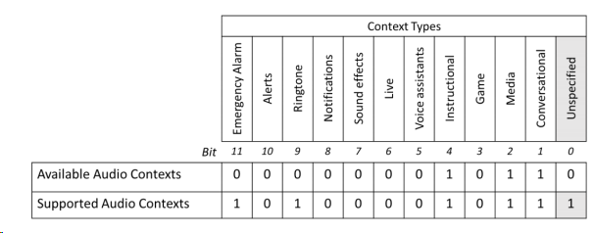

the Acceptor is only available for Audio Streams that are associated with «Instructional», «Media» or «Conversational».